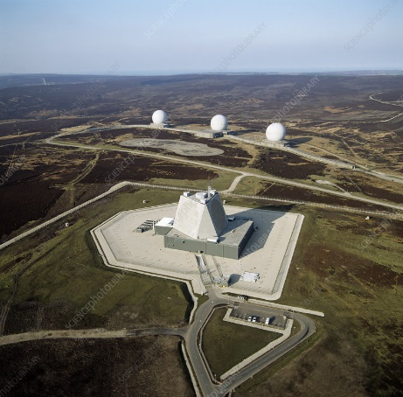
Flyindales Radar Station

Who is responsible for this site
Flyingdales is an RAF installation operated by the RAF
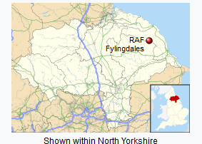
Where is the site located
Flyingdales is located in the North Yorkshire Moors, England.
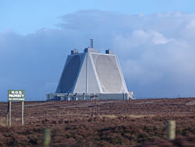
How high is the antenna system at this site
The antenna system is 120 feet tall, consisting of the AESA phased array radar.
Prior to 1989, it was three geodesic radar domes.

When with the site first operational
Flyindales first became operational in 1963 and is still in operation.

Why is this site located in Great Britain
The site, before being converted into a radar base, was originally a wartime mortar range. The site was also an early warning radar station meant for British defense.

What is the purpose of this particular intelligence facility.
Flyindales is a radar installation for long-range (3500 mile) missile warning and has a secondary purpose of tracking of orbital objects.

Is there a similar site in the United States.
This facility is currently part of the BMEWS system, and has a similar site in Clear Space Force Station, Alaska United States, and another in Greenland.

Sources:
https://military-history.fandom.com/wiki/RAF_Fylingdales
BBC. Fylingdales: Radar on the Moors http://news.bbc.co.uk/2/hi/uk_news/2575759.stm
https://www.sciencephoto.com/media/231658/view/raf-fylingdales

